**LIVE TEST - 1**

**Mahir Shadid**

01888504938 – [mahir.shadid@gmail.com](mailto:mahir.shadid@gmail.com)

**TASK-1:** The response shows 201 created perfectly. But shows 400 when a username is already exists.

**TASK-2:** Provided the username and password in the authentication’s basic auth and got expected result. Before blog insertion the response was a blank array.

**TASK-3:** After insertion the response showed the blog details as expected:

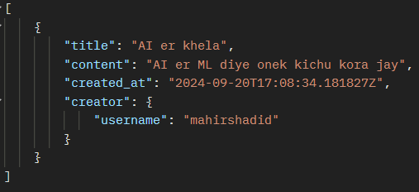

**TASK-4:** Newman report has been generated. It shows 400 Bad Request (FAILED) in newman because of username duplication. Adding new user is always successful.

**POSTMAN URL**: <https://documenter.getpostman.com/view/23199592/2sAXqta1XN>